## **Loading data into Azure SQL Data Warehouse by using Azure Data Factory**

Azure SQL Data Warehouse is a cloud-based, scale-out database that's capable of processing massive volumes of data, both relational and non-relational. SQL Data Warehouse is built on the massively parallel processing (MPP) architecture that's optimized for enterprise data warehouse workloads. It offers cloud elasticity with the flexibility to scale storage and compute independently.

## **Prerequisites**

Before beginning the demo, we need to create the following services.

* **Azure SQL Data Warehouse**: The data warehouse holds the data that's copied over from the SQL database.
* **Azure SQL Database:** This tutorial copies data from an Azure SQL database with Adventure Works LT sample data.
* **Azure storage account:** Azure Storage is used as the *staging* blob in the bulk copy operation.

**Creating Azure SQL Data Warehouse:**

**Step 1:** Sign into your Azure Portal using your credentials and click on **Create a resource** in the upper left-hand corner of the Azure portal and select **SQL Data Warehouse** from the **Databases** category. Fill the necessary details as below to create your SQL Data Warehouse

**Database name**: Any name as an identifier

**Subscription:** Select your subscription

**Resource group**: Create a new resource group with a name

**Select source**: Select sample

**Select sample:** Blank database

**Server:** Create a new server with unique name and login creadentails. Select a location nearest to you.

**Perfomance level:** Select DW400 (default)

Click on **Create** to provision the database and wait for few mintues for the provision to be succeded.

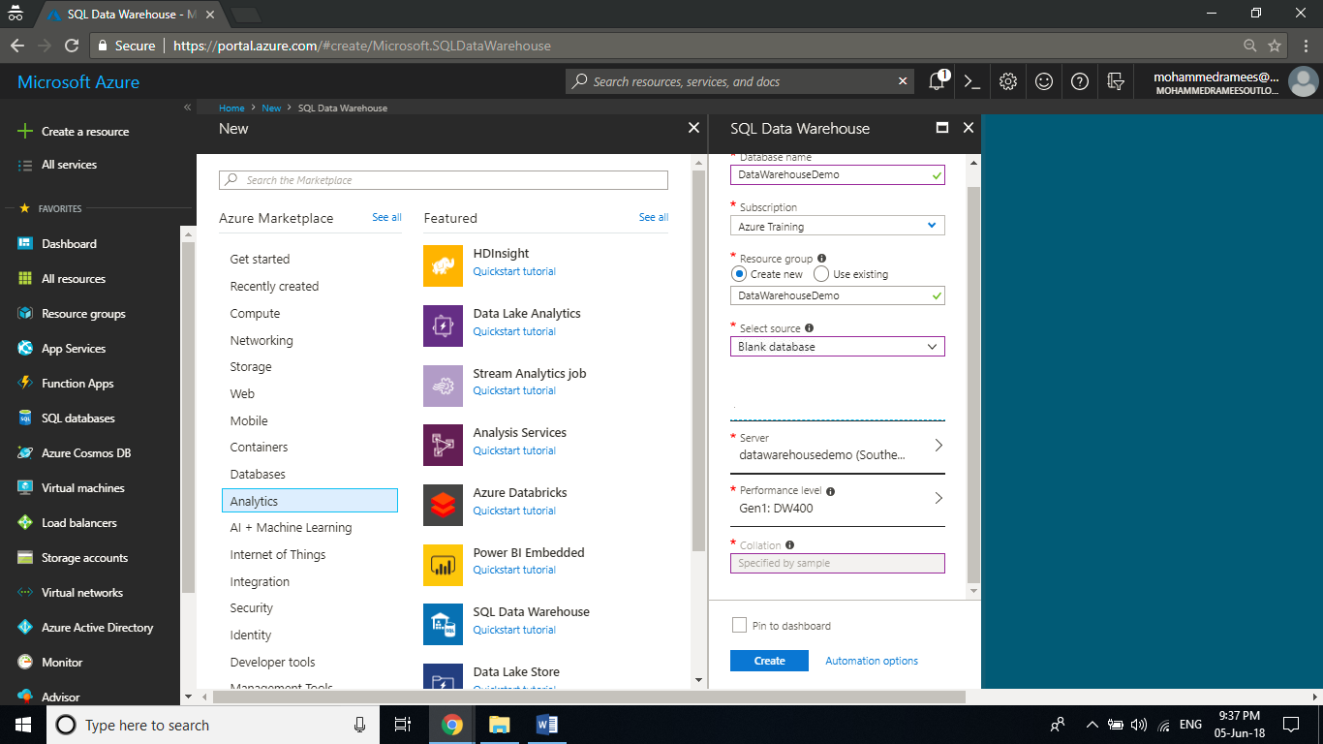

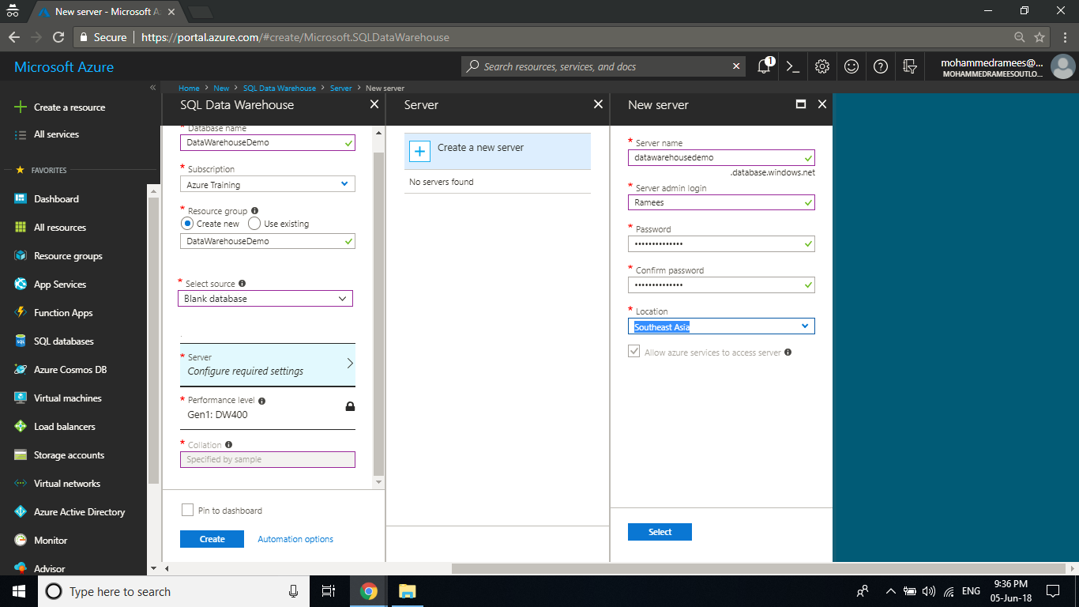

**Step 2:** Once the provision is completed open the resource and you can see the settings blade for the newly created Azure Data Warehouse. Click on the **Server name** to open the settings for the server.

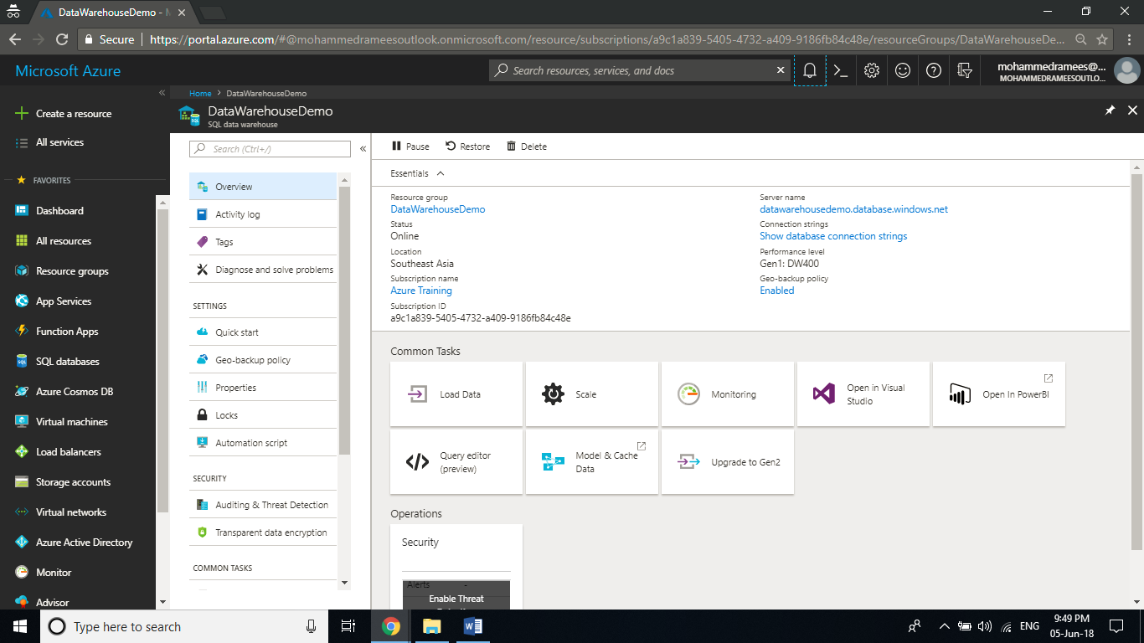

**Step 3:** Now you have got the settings for the server. The SQL Data Warehouse service creates a firewall at the server-level that prevents external applications and tools from connecting to the server or any databases on the server. To enable connectivity, you can add firewall rules that enable connectivity for specific IP addresses. Click on **Show Firewall** **settings** to create a server-level firewall rule for your client's IP address.

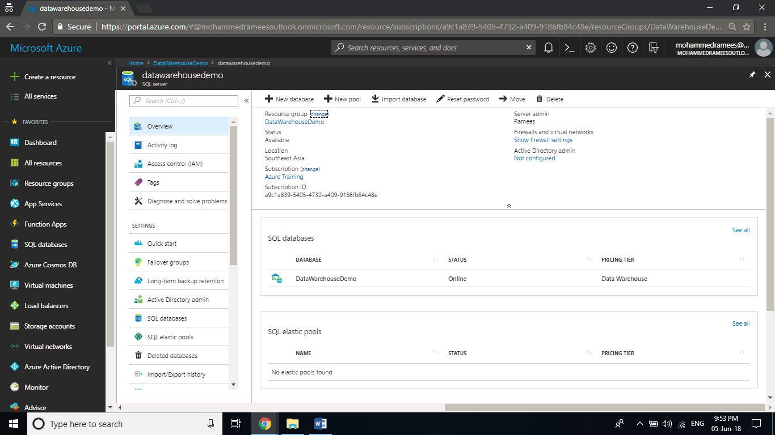

**Step 4:** It will open the List of Client IPs allowed to access the server. Click on **Add client IP** to add your current IP address, and click on **Save** to save the changes. A firewall rule can open port 1433 for a single IP address or a range of IP addresses.

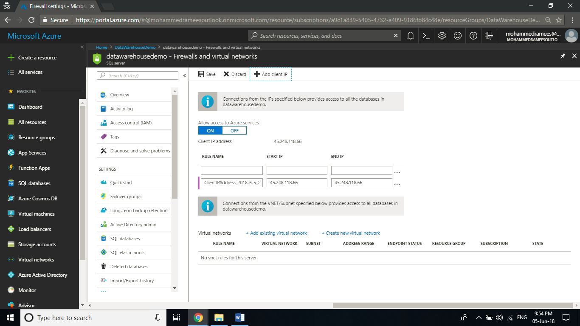

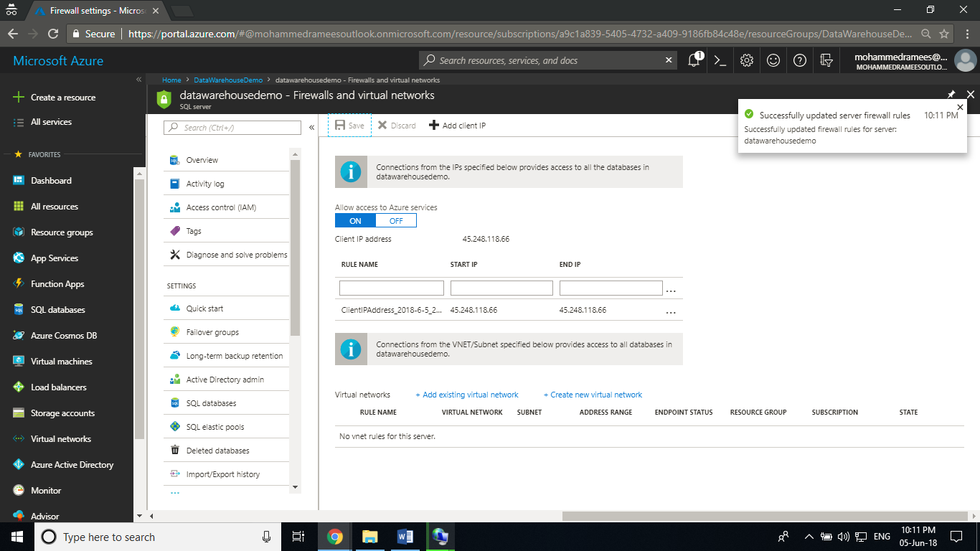

**Creating SQL DB:**

In the azure portal, go to **+ Create a resource -> Database -> SQL Database.**

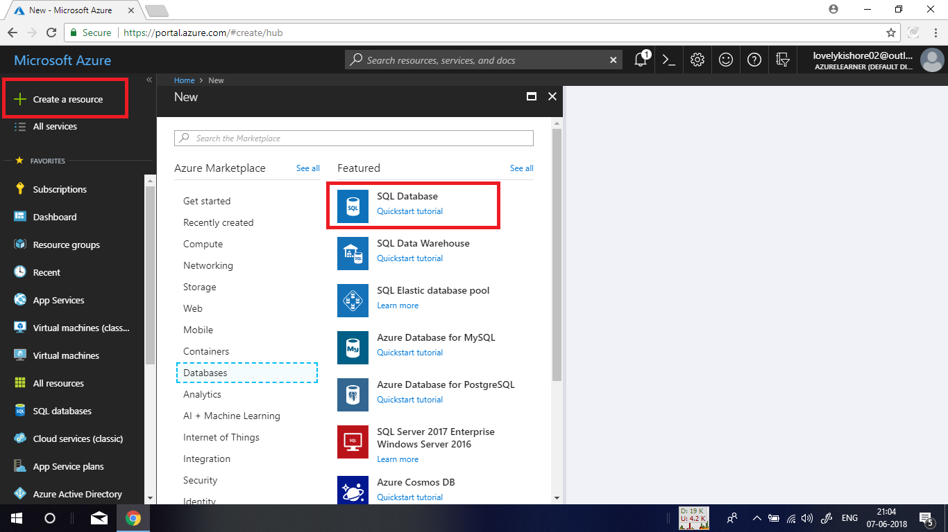

Give an unique name and choose a subscription and a resource group. Select the Data Source as **Sample(AdventureWorksLT)**. Create a server with a name and username and password or choose an existing one if you already have any as denoted in the below given image and deploy the database.

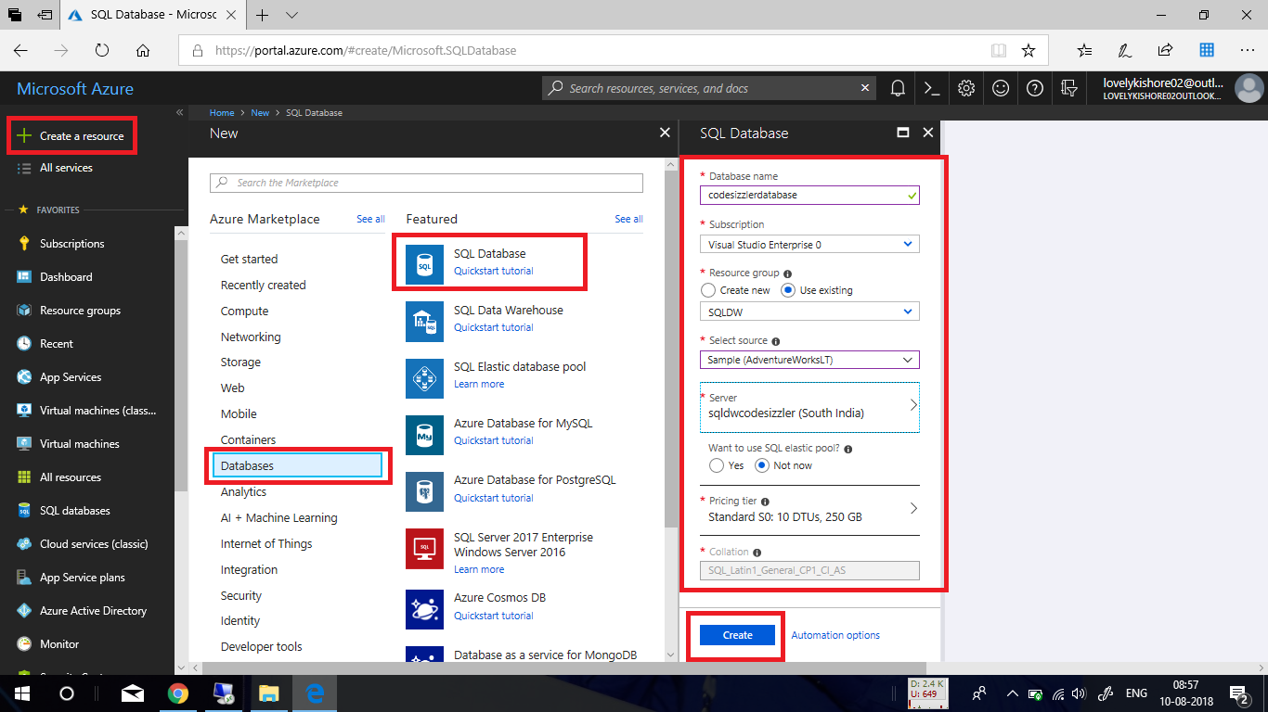

**Configuring Firewall:**

In the overview bladed of database, click on the set server firewall option to configure access to the server.

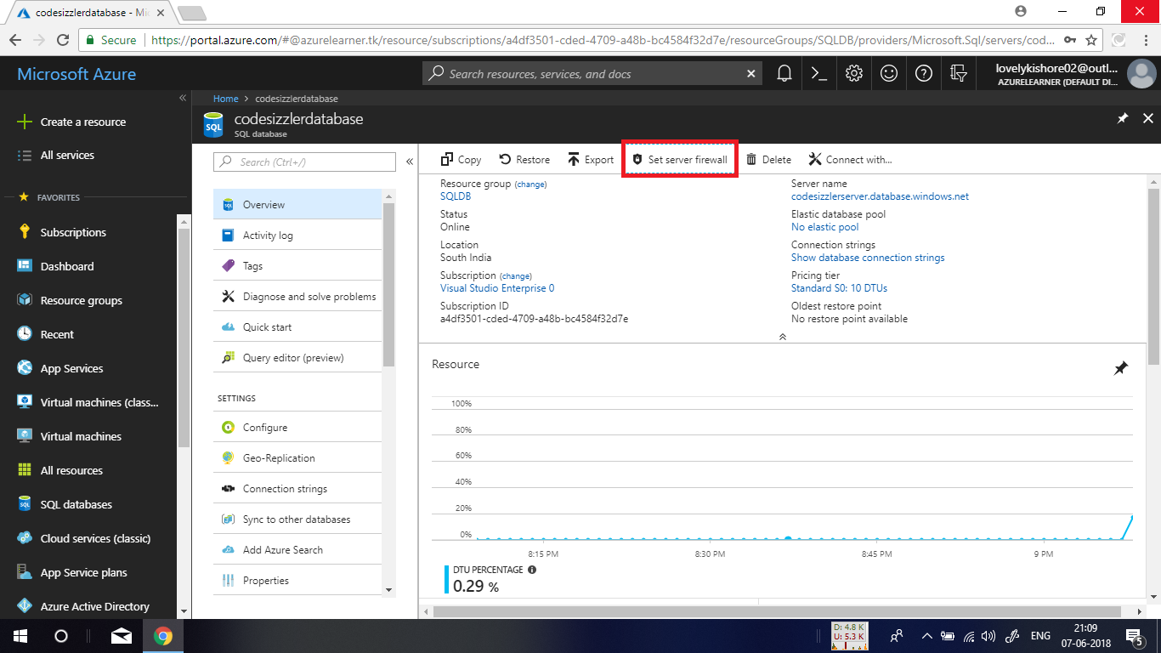

After that click on the **+** **Add client IP** option to add your machines IP to have access to the server. If in case you want to allow access for an entire organization, you can manually add the IP ranges as allowed address in the option denoted below. After adding the IP, click on save button.

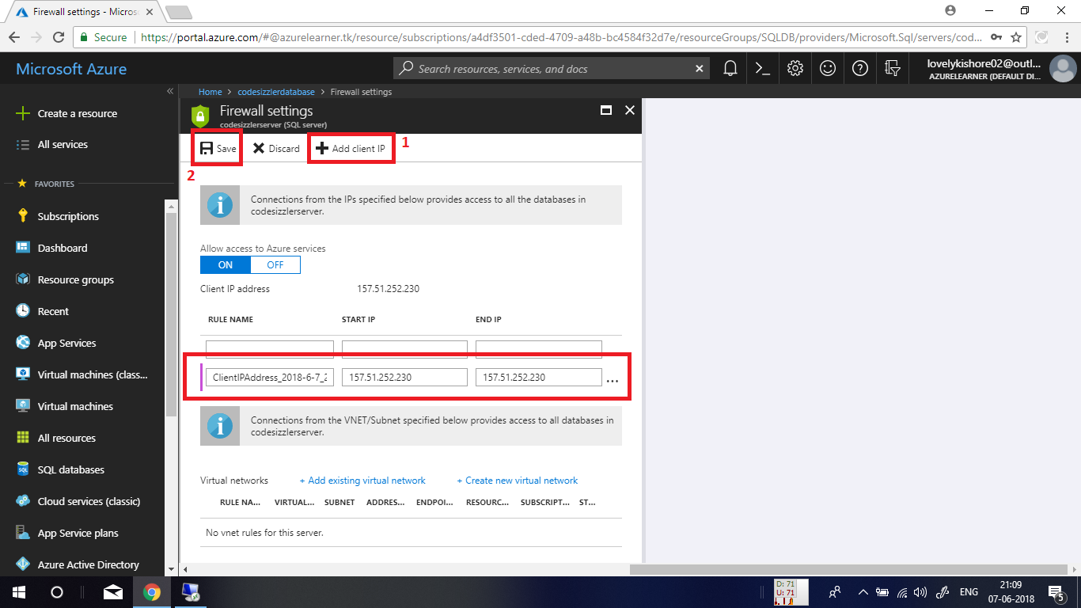

**Creating Storage Account:**

**Step 1:** Login to your Microsoft Azure portal, click on **Create new resource** and select **Storage account - blob, file, table, queue** from **Storage** category to create a **Storage account** and give the necessary details as follows.

**Name:** A Unique Name

**Deployment:** Resource manager

**Account kind:** General purpose

**Location:** Nearest to you

**Replication**: Locally-redundant storage

**Performance:** Standard (For premium only LRS replication is available as of now)

**Secure Transfer Required:** Disabled

**Resource group**: Choose already available resource group

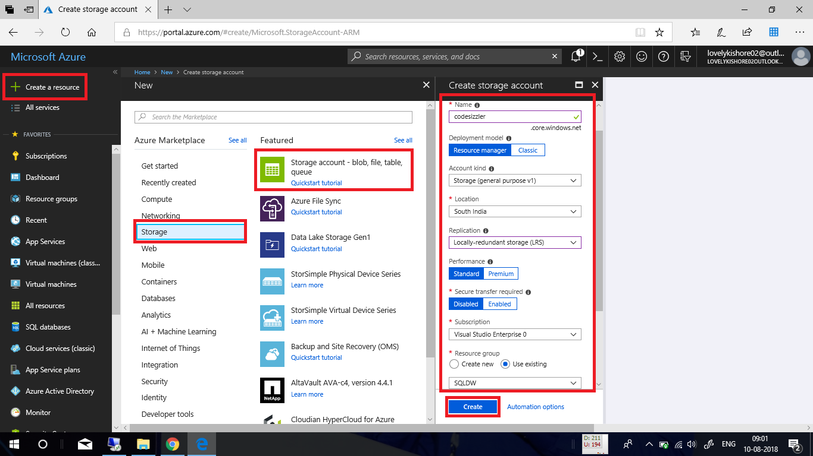

**Creating Data Factory:**

In the Azure portal, go to **+ Create Resource -> Analytics -> Data Factory.** Give a **name** for the resource, select a **subscription**, a **resource group**, **version**, **location** and click on **Create.**

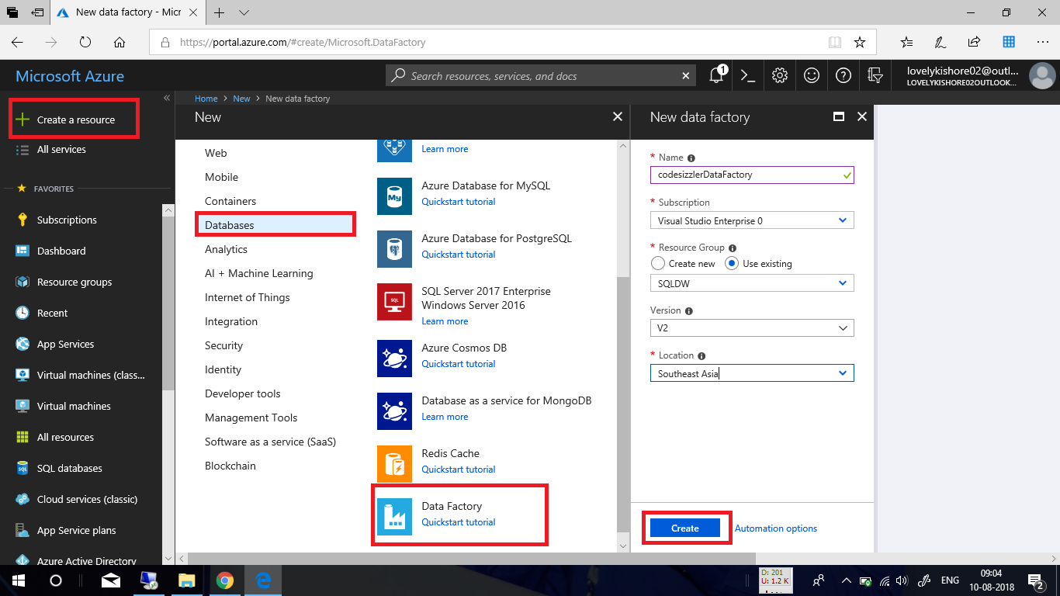

In the overview page of the data factory, click on **Author & Monitor** tile to navigate into management portal of azure data factory.

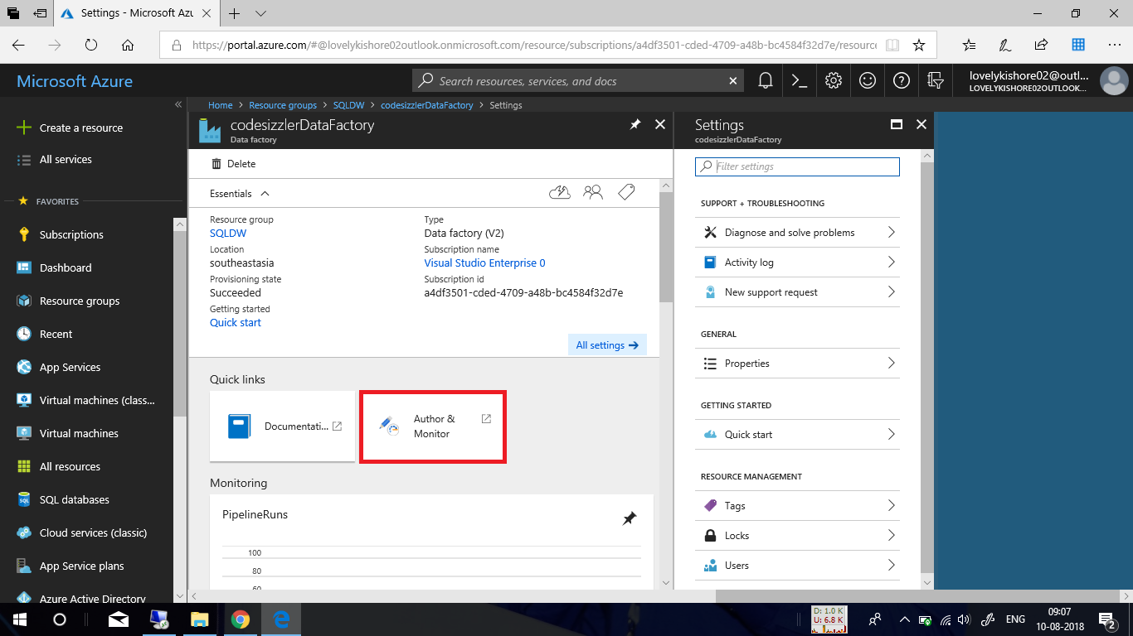

## **Load data into Azure SQL Data Warehouse**

In the **Get started** page, select the **Copy Data** tile to launch the Copy Data tool.

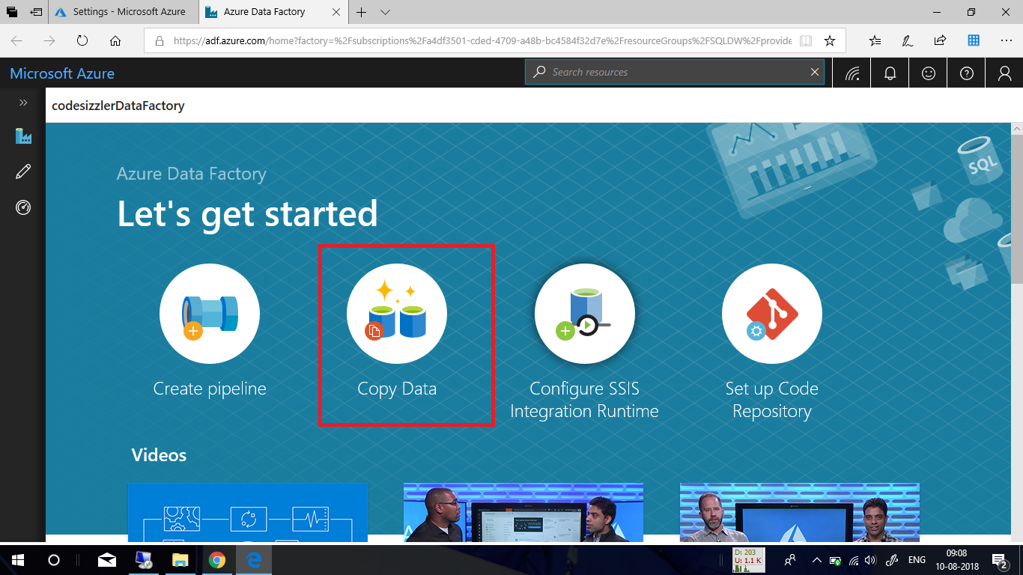

In the **Properties** page, specify **CopyFromSQLToSQLDW** for the **Task name** field, and select **Next**.

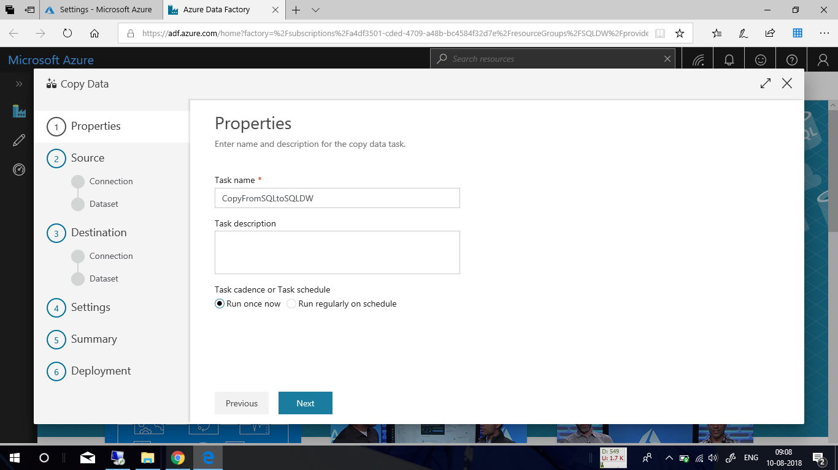

In the **Source data store** page, click **+ Create new connection**.

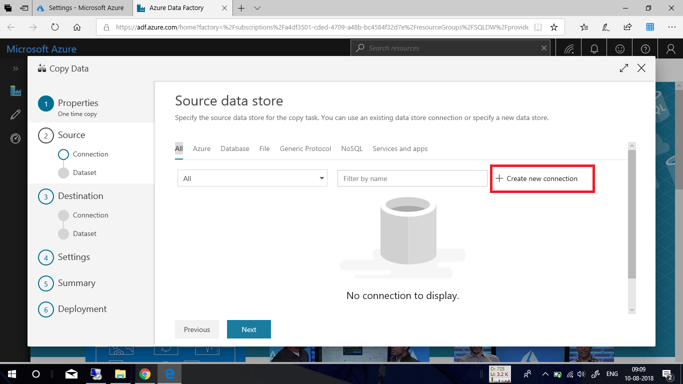

Select **Azure SQL Database** from the gallery and select **Continue**. You can type "SQL" in the search box to filter the connectors.

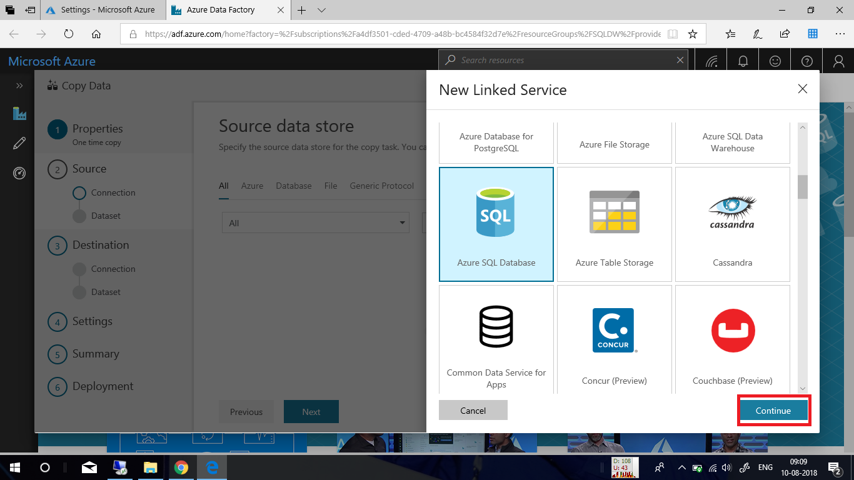

In the **New Linked Service** page, select your server name and DB name from the dropdown list, and specify the username and password. Click **Test connection** to validate the settings, then select **Finish**.

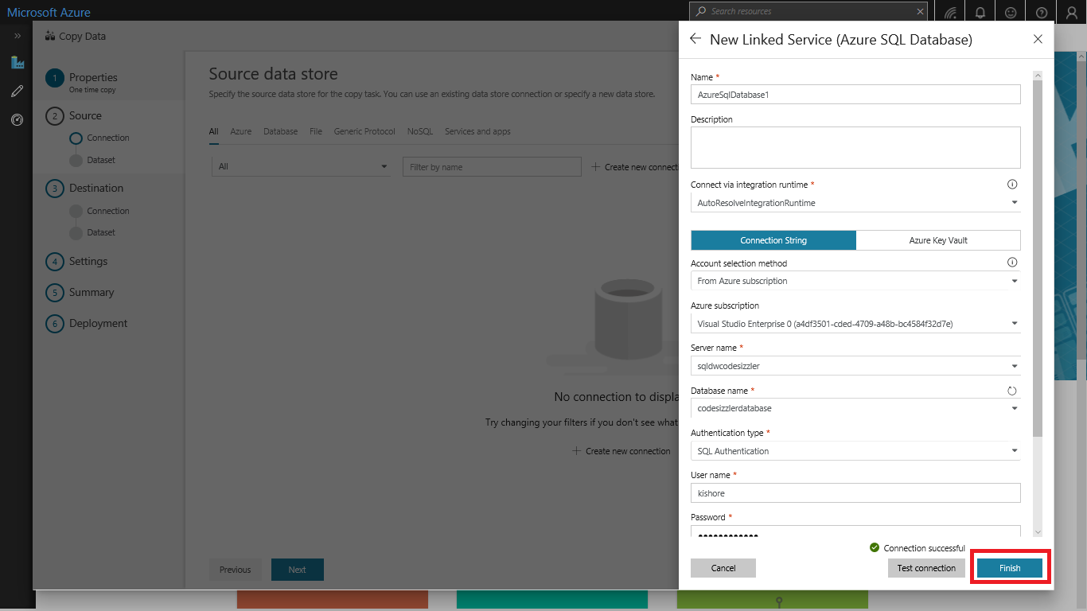

Select the newly created linked service as source, then click **Next**.

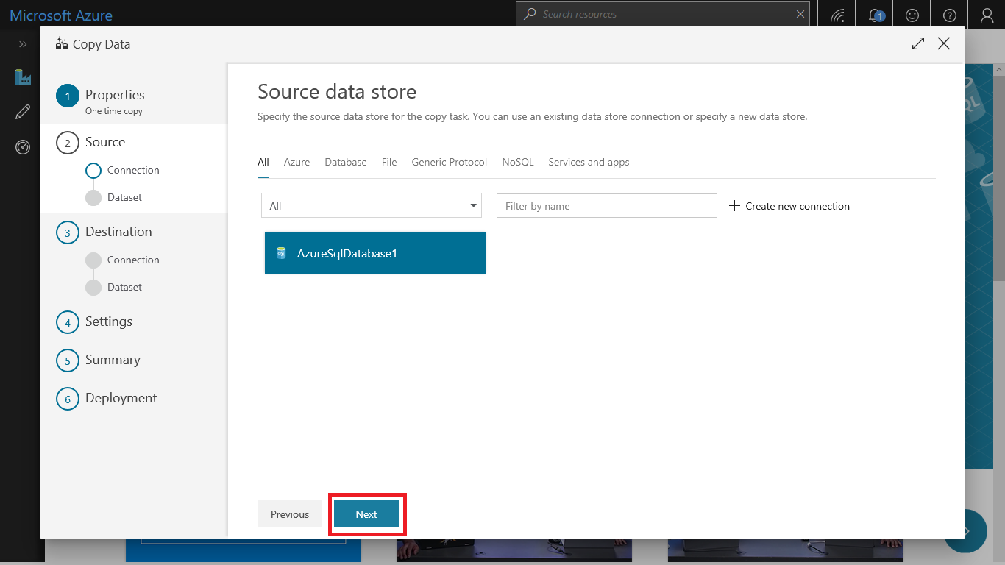

In the **Select tables from which to copy the data or use a custom query** page, enter **SalesLT** to filter the tables. Choose the **(Select all)** box to use all of the tables for the copy, and then select **Next**.

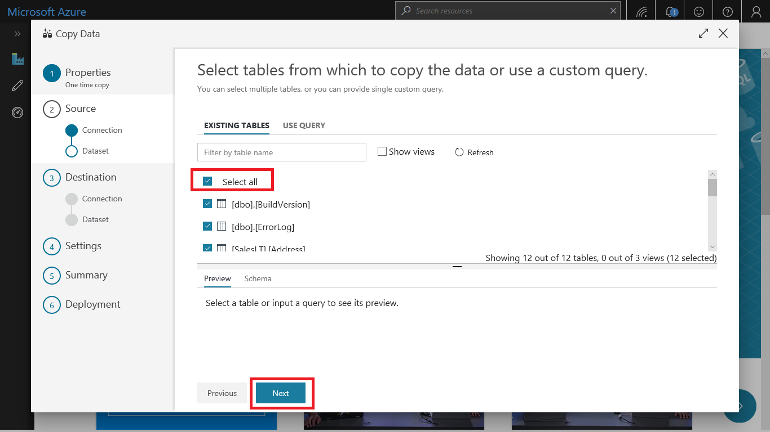

In the **Destination data store** page, Click **+ Create new connection** to add a connection.

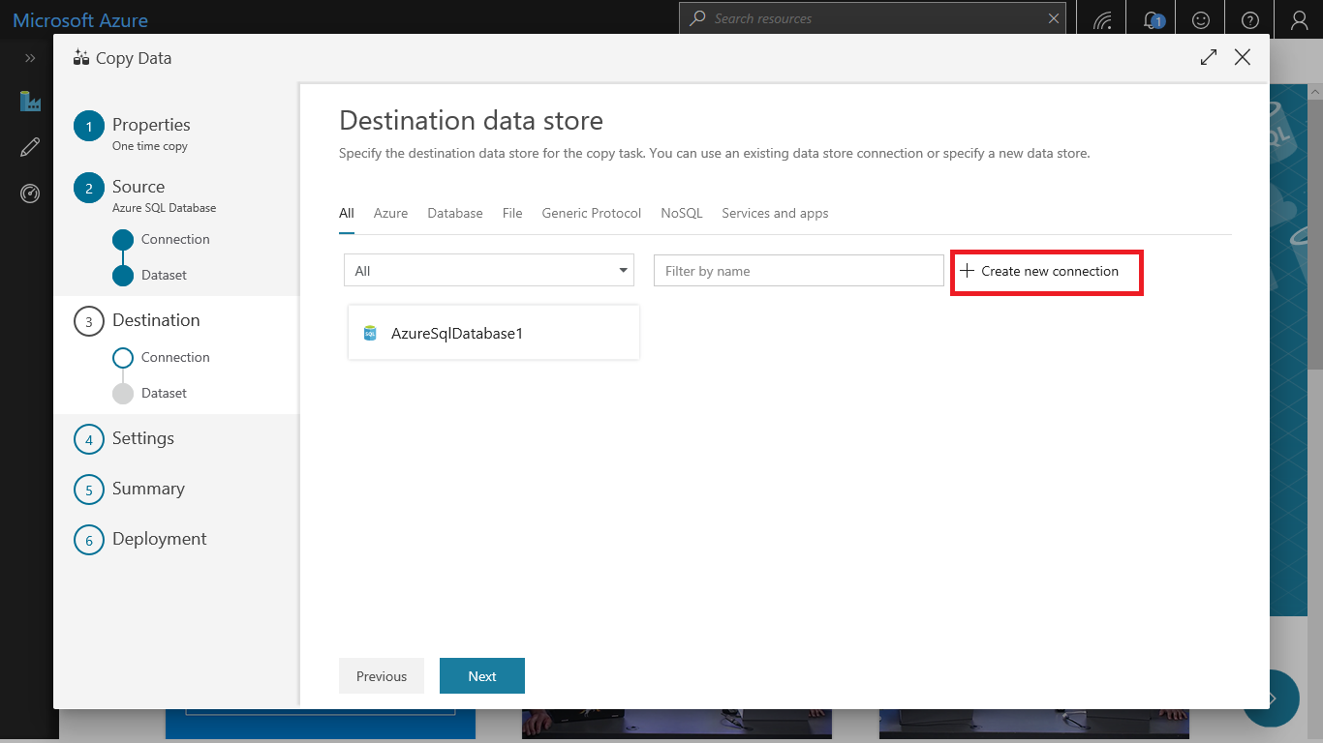

Select **Azure SQL Data Warehouse** from the gallery and select **Continue**.

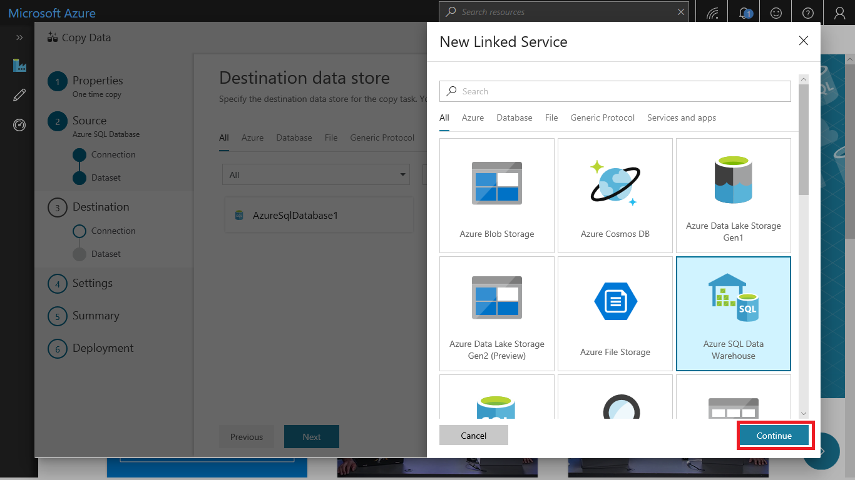

In the **New Linked Service** page, select your server name and DB name from the dropdown list, and specify the username and password. Click **Test connection** to validate the settings, then select **Finish**.

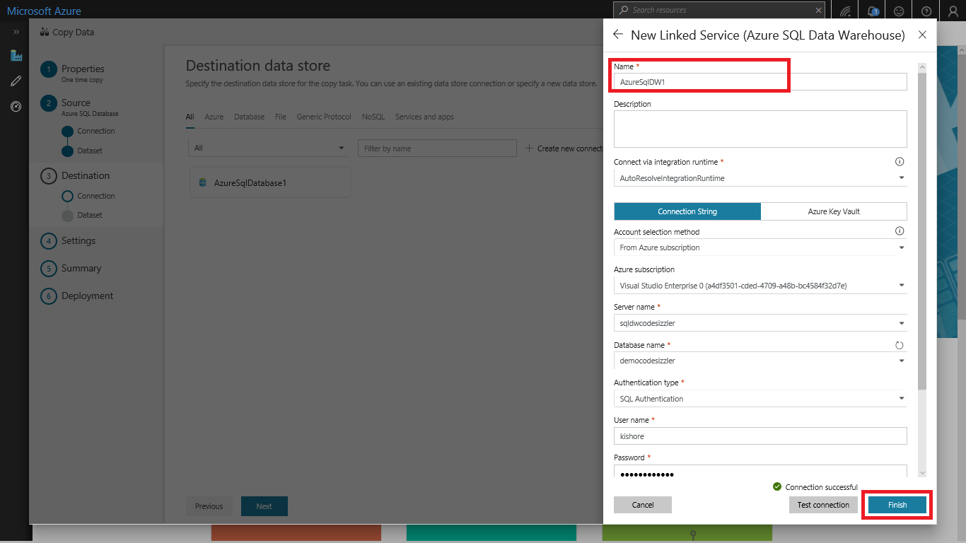

Select the newly created linked service as sink, then click **Next**.

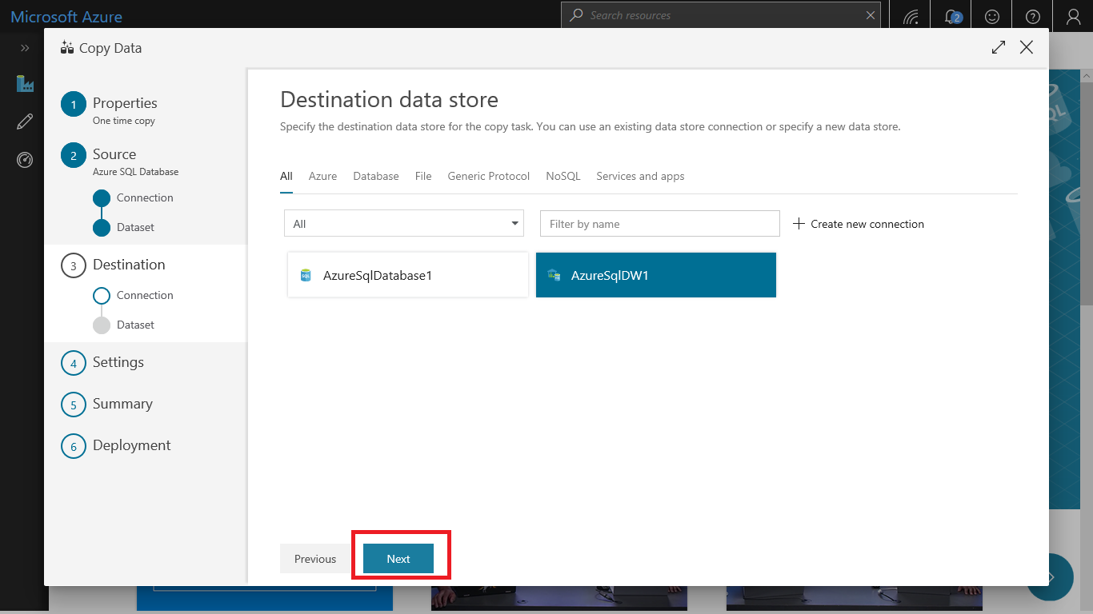

In the **Table mapping** page, review the content, and select **Next**. An intelligent table mapping display. The source tables are mapped to the destination tables based on the table names. If a source table doesn't exist in the destination, Azure Data Factory creates a destination table with the same name by default. You can also map a source table to an existing destination table.

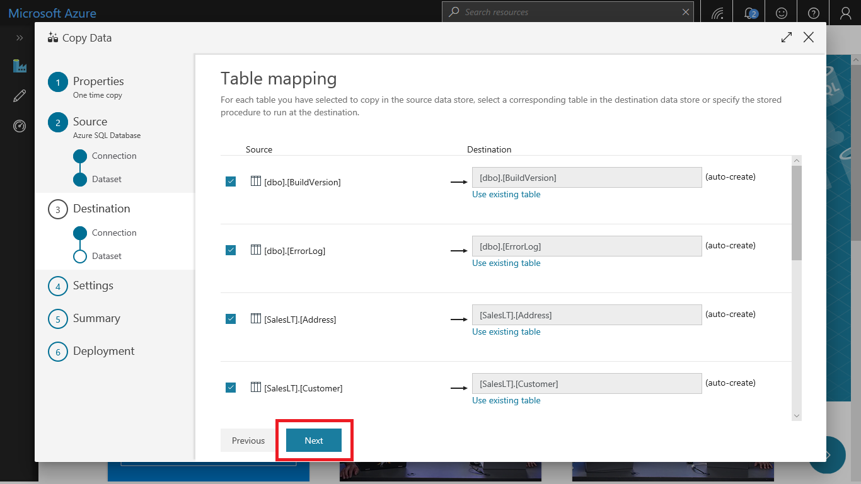

In the **Schema mapping** page, review the content, and select **Next**. The intelligent table mapping is based on the column name. If you let Data Factory automatically create the tables, data type conversion can occur when there are incompatibilities between the source and destination stores. If there's an unsupported data type conversion between the source and destination column, you see an error message next to the corresponding table.

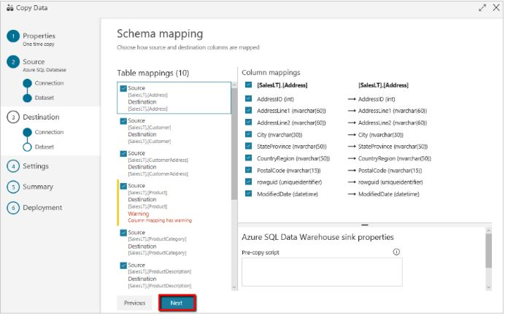

In **Staging settings** section, click **+ New** to new a staging storage. The storage is used for staging the data before it loads into SQL Data Warehouse by using PolyBase. After the copy is complete, the interim data in Azure Storage is automatically cleaned up.

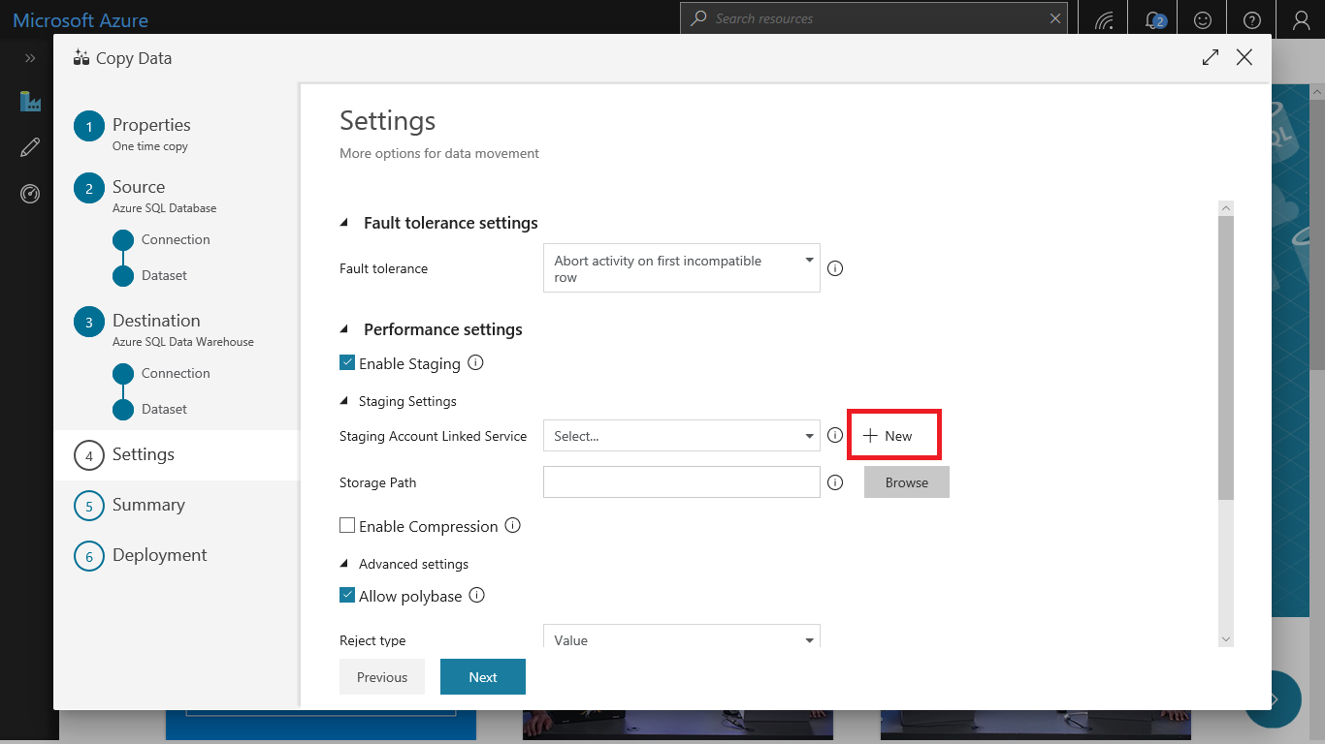

In the **New Linked Service** page, select your storage account, and select **Finish. Then click Next.**

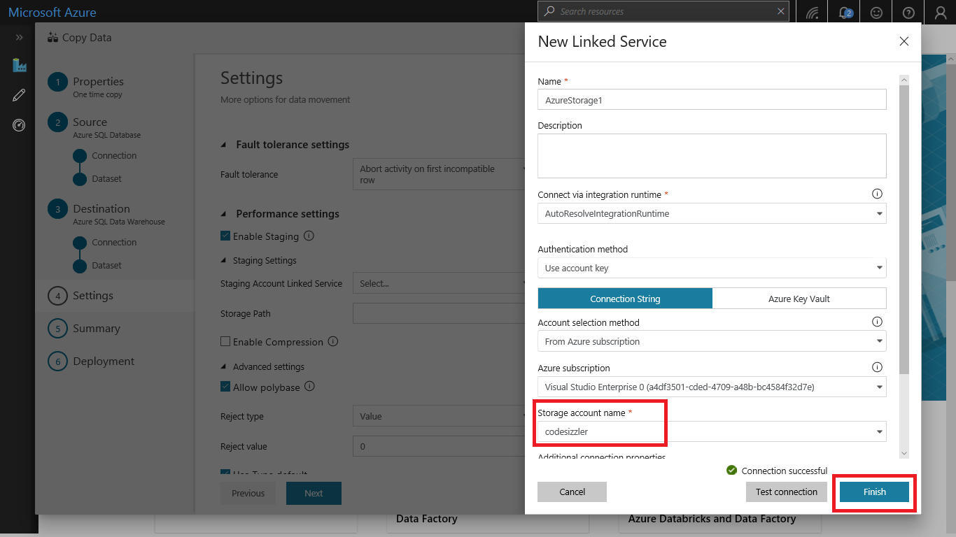

In the **Summary** page, review the settings, and select **Next**.

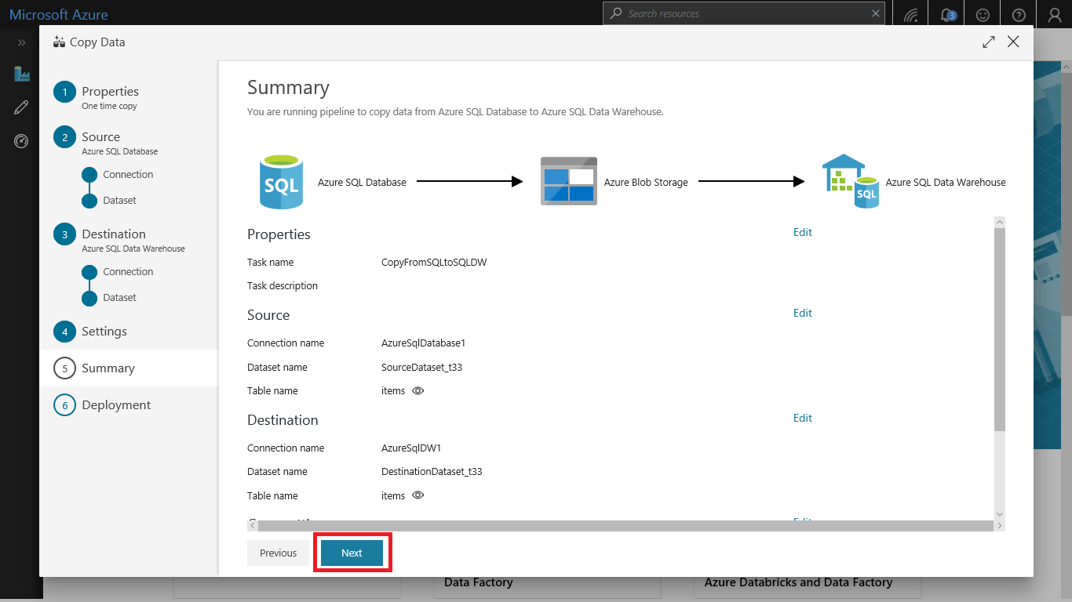

In the **Deployment page**, select **Monitor** to monitor the pipeline.

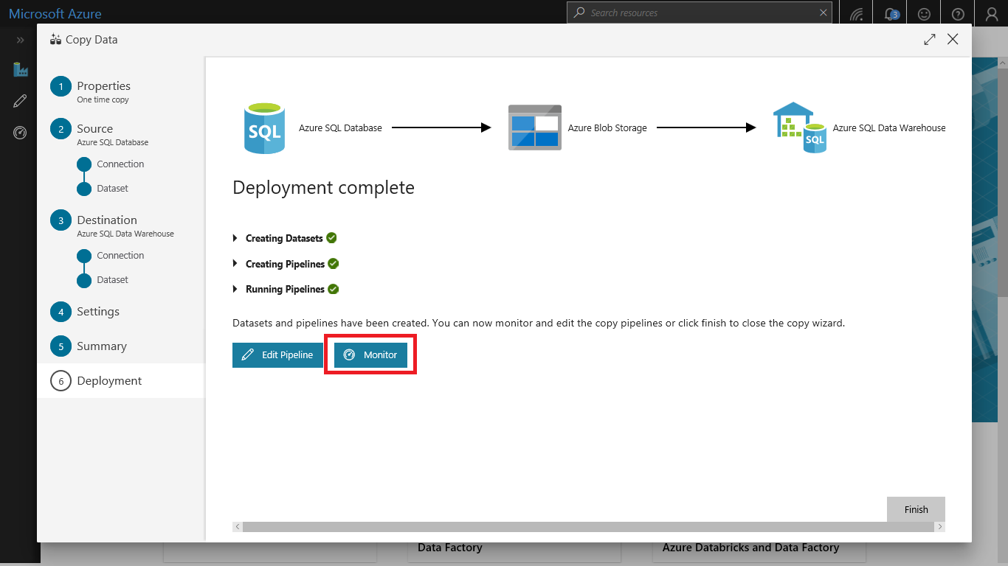

Notice that the **Monitor** tab on the left is automatically selected. The **Actions** column includes links to view activity run details and to rerun the pipeline.

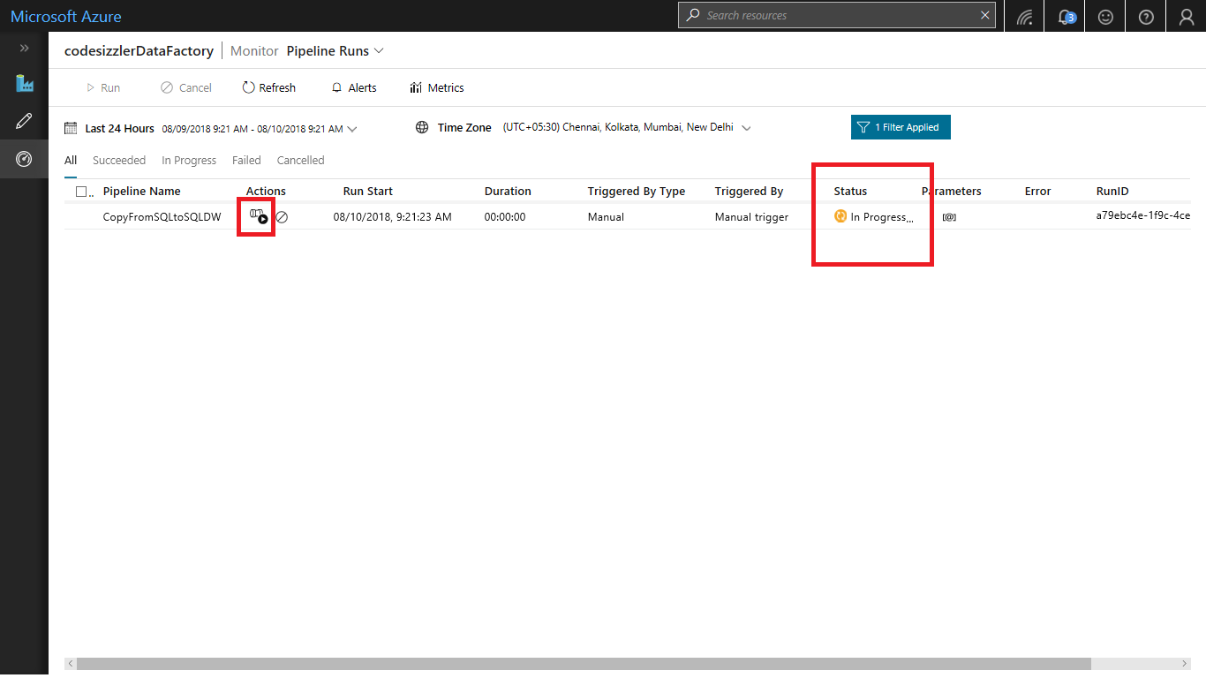

To view activity runs that are associated with the pipeline run, select the **View Activity Runs** link in the **Actions** column. To switch back to the pipeline runs view, select the **Pipelines** link at the top. Select **Refresh** to refresh the list.

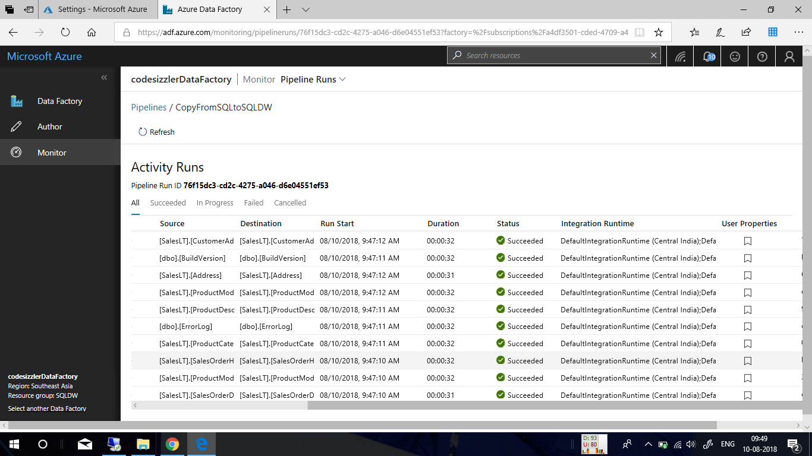

To monitor the execution details for each copy activity, select the **Details** link under **Actions** in the activity monitoring view. You can monitor details like the volume of data copied from the source to the sink, data throughput, execution steps with corresponding duration, and used configurations.

